10 References to Web Resources
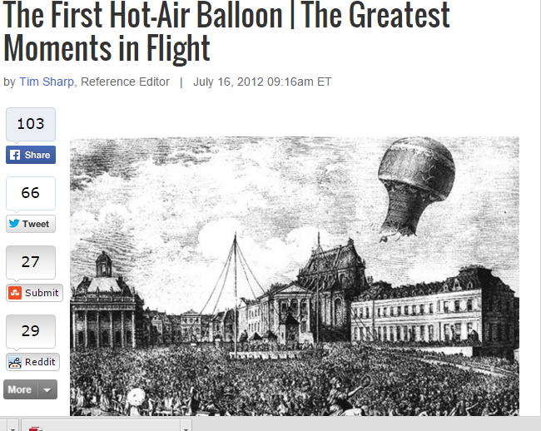
The First Hot Air Balloon
http://www.space.com/16595-montgolfiers-first-balloon-flight.html
This web page gives students information about the first hot air balloon flight and the advances made to the invention.

PBS Kids- Hot Air Balloon Activities
http://pbskids.org/zoom/activities/sci/hotairballoon.html
This is a great enrichment website that allows children to create their own hot air balloon so they can experience the lift off themselves.

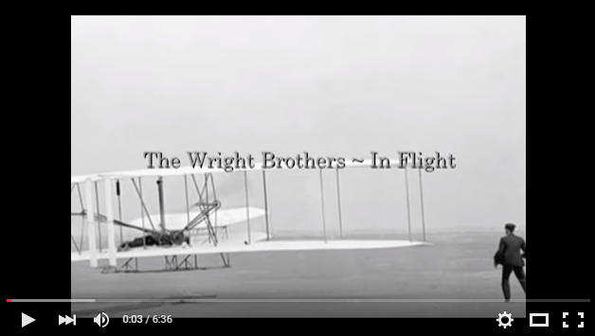
Wilbur and Orville Wright Video
https://www.youtube.com/watch?v=q3beVhDiyio
This is a video that shows the life of Wilbur and Orville Wright and the creation of their first plane.
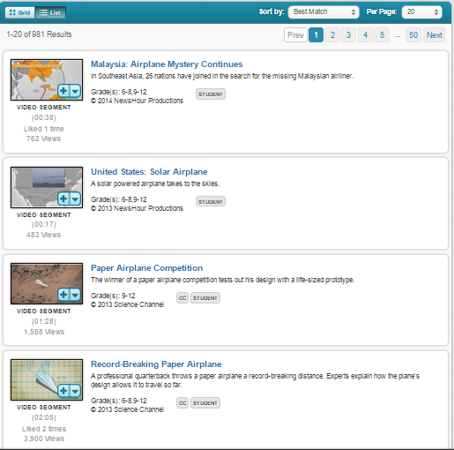
Discovery Education Boards
http://app.discoveryeducation.com/search?Ntt=airplane
This is a technology connection that the students can visit to learn more about present-day airplanes.

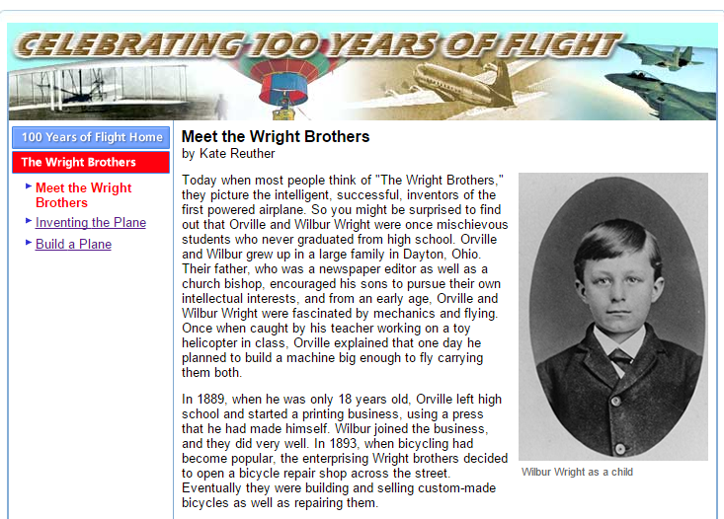
Wright Brothers Biography and Activities
http://teacher.scholastic.com/activities/flight/wright/index.htm
This website can be used for students to extend their knowledge about the Wright Brothers. There is a brief biography to give information on the Wright Brothers and how they invented the plane. There is also an additional link where students can create a virtual plane, simulating the steps the Wright Brothers used.

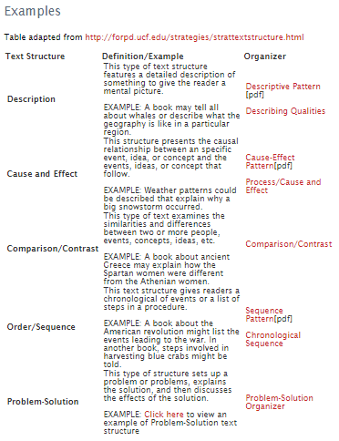
Text Structure Information and Examples
http://www.adlit.org/strategies/23336/
This website give examples of text structures and organizers to help students better understand the different types of text structures. Additional links are provided to give extra assistance as well.

History of Aviation
https://youtu.be/GLAreFQ3G5k
This is a video where the students could watch the complete history of aviation in a kid friendly animated format.

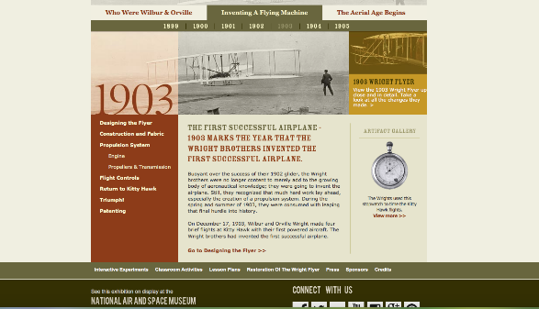
Air and Space Museum
http://airandspace.si.edu/exhibitions/wright-brothers/online/
This website would be used as an extension activity. The students could visit this website and learn more in depth information about the planes that the Wright Brothers.

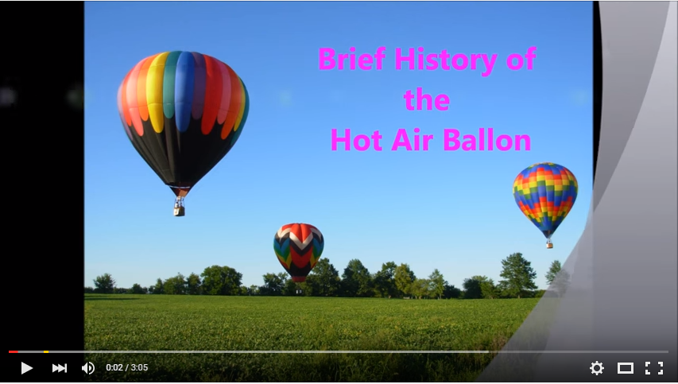
History of the Hot Air Balloon
https://www.youtube.com/watch?v=eGgqU98eBzg
This video on the history of hot air balloons will allow student to travel through time to see detailed pictures and facts on the how the hot air balloon came about. This technology allows visual learners to have a chance to have a chance to learn and understand hot air balloon history.

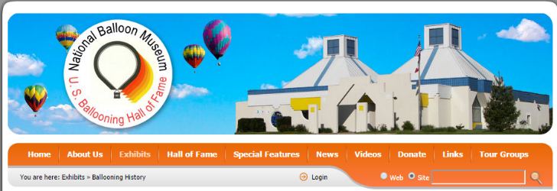
National Balloon Museum
http://www.nationalballoonmuseum.com/Exhibits/
BallooningHistory.aspx
The National Balloon Museum technology link allows students to get a better understanding about hot air balloons. They can click on links on the website to watch videos, see new news about hot air balloons, hot air balloon hall of fame, exhibits that can be seen, and special features of hot air balloons. Taking ballooning to a new age and learning of the hot air balloon even further.

