Name of Lesson | Building Vocabulary and Analyzing Illustrations (6)
Assessment | Original Assessment without Technology: Reader Response Log(s): Explain how one of the illustrations or photographs on pages 307 – 308 helps you understand where, when, or how early flights took place.  New Assessment with Technology: Students will create an illustration using the program, Wixie, that would be helpful to have in the text. They will explain how this new illustration helps them understand where, when, or how early flights took place.
Assessments
Example Wixie: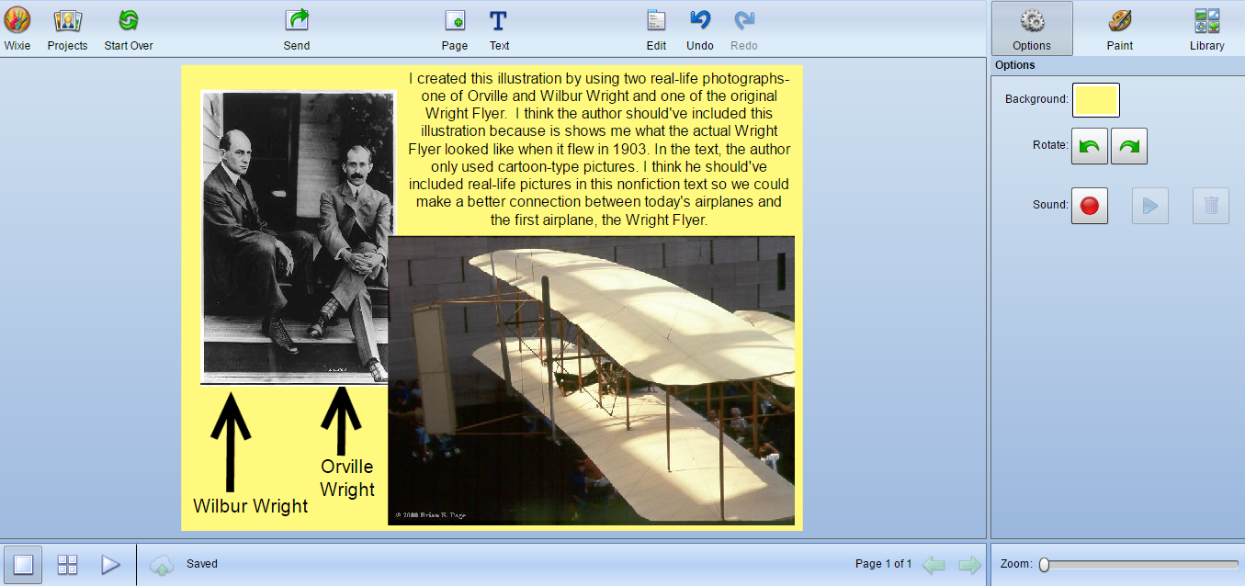
Assessment | Completed Sequence Chain on Word, Answers on Padlet  - Example Sequence Chain  - http://padlet.com/rrembold/abr04o8aerp3

Name of Lesson | Describing the Relationship between a Series of Historical Events (7)

Name of Lesson | Describing Relationships Between Events (8)
Assessment | Write a brief description about the relationship between your two events. What changed or improved? Be sure to include details about time, sequence, and cause/effect.  In a series of events, one event leads to another. How did hot-air balloons change over time? What were some of the inventions and innovations?  Work as a team (3 students) to create a graphic for an exhibit at a hot-air balloon festival, showing some events in the history of ballooning. Each team member is responsible for two events, providing visuals with captions. Sequence the events as a group.  Product options may include a sequence chain, timeline, poster, pamphlet, flyer, foldable, or media.  Example of Assessment (Powerpoint)

Name of Lesson | Important Points and Key Details Presented in Two Texts (9)
Assessment | Venn diagram using Discovery Board  Example Venn Diagram  http://bcps.discoveryeducation.com/builders/boards/assetGuid/17C5E8B7-E4C8-28C3-62E6-EFCC9560E839/#mode=preview
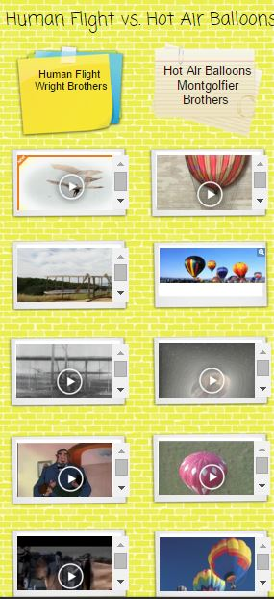
BoardBuilder:

Name of Lesson | Logical Connections between Sentences (10)
Assessment | Formative: Padlet posts/discussions  http://padlet.com/gantalffy/flylikebirds  Summative: Socrative quiz (Student Paced) with the following questions:  Connecting Ideas between Sentences  Gliders  Part A: What is the main idea in Paragraph 1 of the section “Gliders?”  Gliders were an improvement over balloons.  Part B: What is the best way to describe how the sentences in the paragraph are connected?  a. They contrast the attributes of gliders and balloons.  b. They show the sequence of steps used to create the glider.  c. They show the similarities between gliders and balloons.  d. They show how the invention of the balloon led to the invention of the glider.  Really Flying  Part A: What is the primary purpose of Paragraph 2 of the section “Really Flying?”  a. To explain how far Orville Wright flew when testing the “Flyer.” b. To explain why the Wright brothers chose to create an airplane.  c. To explain the process the Wright brothers followed when creating and modifying their flying machine.  d. To support the idea that the brothers were very intelligent.  Part B: What is the best way to describe how the sentences in the paragraph are connected?  They sequence the steps in the technical process used by the Wright brothers.
Example Socrative:
: 